Logistic Infotech

Basic Training Document
Created at July 24, 2017 - by Nirav Adatiya (Last Updated at Jun 11, 2018)

1. This is basic example in Javascript

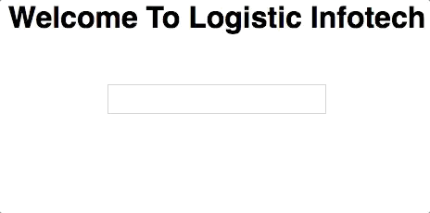
This example with JS , when user enter something in textbox it should be written in < p > tag synchronously.
© Logistic Infotech Pvt. Ltd.

2. Show / Hide HTML tag on button click.

Show and Hide <p> tag with this two buttons buttons.

3. Show result of Price into Quantity.
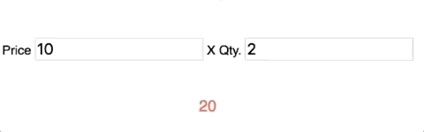
Make two textbox one for price another for quantity and show multiplication of both textbox to <p> tag.
© Logistic Infotech Pvt. Ltd.

4. Celsius to Fahrenheit converter.

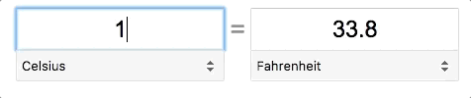
Make two textbox one for Celsius another for Fahrenheit and show result synchronously.

5. Add Dropdown menu and make Time Converter.
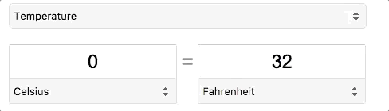
Add Dropdown menu to Celsius to Fahrenheit converter where user can select time converter. Make time converter - from Second to Minute and set default seconds value to 3600.

© Logistic Infotech Pvt. Ltd.

6. RGB Color Chooser
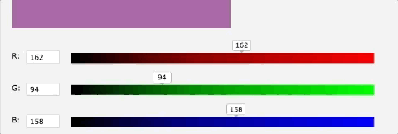
Create RGB color chooser which is showing Preview like above example.

7. Clone HTML & Append To Body on Click.
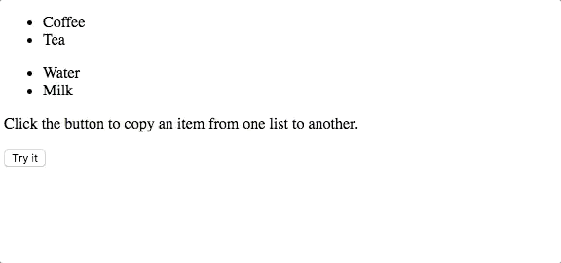
Simply Clone from one List to another on button click.

8. Increment Decrement Value.

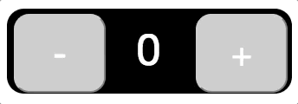
Increment Decrement value on button click.

9. Clone Increment Decrement Div on Click.


Clone Increment Decrement div on “New Button” click and it must be functional like above example.
© Logistic Infotech Pvt. Ltd.

10. Click to clone div,add data ,save on submit.

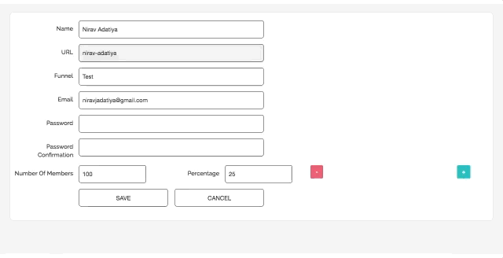
When user click on the right plus button “Number of Member and Percentage” textbox should be added and append. After adding the value on save click data should be save , if field is not filled show validation message on save click button. Clicking on minus button should delete both textbox.

© Logistic Infotech Pvt. Ltd.

11. Add, Edit, Delete User

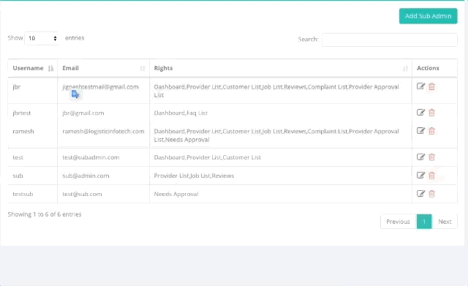
On click Add button show model to add user or redirect to add user page, on submit user should add to Table , on click edit show user edit dialog with submit button, on delete click that row should be remove from database.

© Logistic Infotech Pvt. Ltd.

12. Rows/page, Sorting, Searching with Pagination.

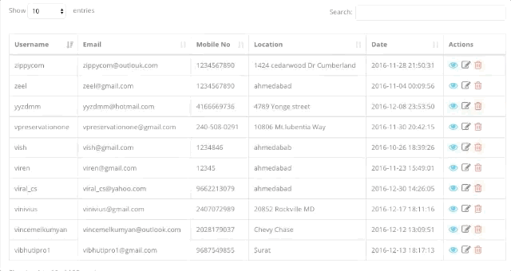
Do Pagination with searching sorting and limit of records per page, also provide check box for multi record delete and check all option on left top corner

© Logistic Infotech Pvt. Ltd.

13. Country City State with Ajax PHP

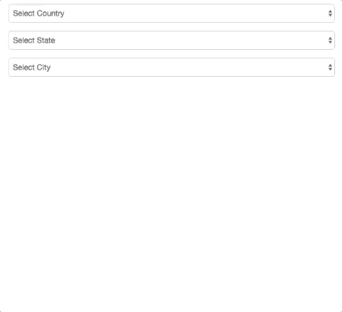
Create Three drop down list for Country, State and City get list from your own api via Ajax.
© Logistic Infotech Pvt. Ltd.

14. The Movie Db Api

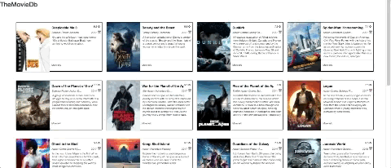

Sign up to TheMovieDB and get API key, Show data like above example,set button on bottom left side corner - LOAD MORE, on click that button should load more data from the same api and append to same doc, when user click on title or photo user should redirect to that movies page on movie db web site.

© Logistic Infotech Pvt. Ltd.

15. Datatables

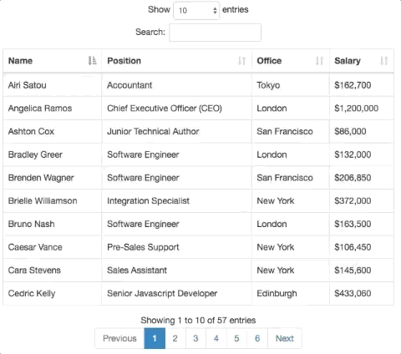
Make Datatables Demo with sorting searching paging add edit delete and limit records per page. Paging should also available on search result

16. Select 2 Demo.

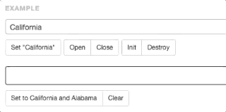

Make Select2 demo as per above example.

© Logistic Infotech Pvt. Ltd.

17. Item Draggable and Sortable

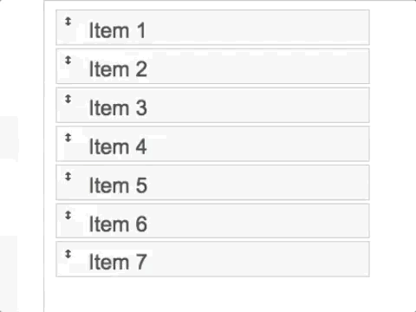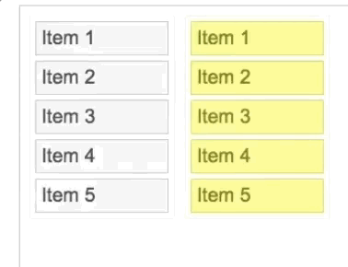

Make Category Draggable and Sortable like above example, on sorting and dragging from one to another table order should be saved on database via ajax.

© Logistic Infotech Pvt. Ltd.
18. Draggable and Sortable with Multiple Table.

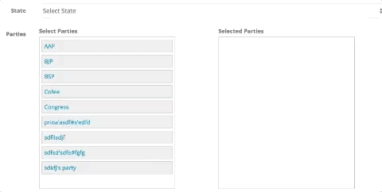

Create 3 tables, one for product list and another two for that product category, User can drag and drop from one table to another and also change table with drop down menu.

© Logistic Infotech Pvt. Ltd.

19. Make Calculator

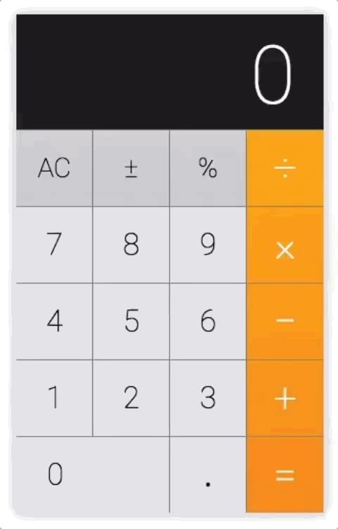
Make Calculator like above example.

© Logistic Infotech Pvt. Ltd.

20. Make your own jQuery widget



Make your custom widget with jQuery Widget Factory. For example we use Datatables like $('#myTable').DataTable(); this.
So our widget usage should be like $('#myTable').myCustomWidget();

© Logistic Infotech Pvt. Ltd.
401 Jaynath Complex, Makkam Chowk Gondal Road, Rajkot.
Suggest edits if any at nirav@logisticinfotech.com

21. File Upload With Form and Ajax

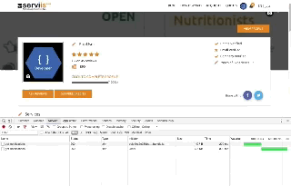

=> Simple Upload file with Form and Ajax.
=> After that do the same thing with cropperjs library.

